PROGRAM:

<!--Image tag-->

<html>

<head>

<title>exe18</title>

</head>

<p align="center">rj</p>

<center><img src="rj1.jpg" alt="Smiley face" width="400" height="350" border="5"></center>

</html>

OUTPUT:

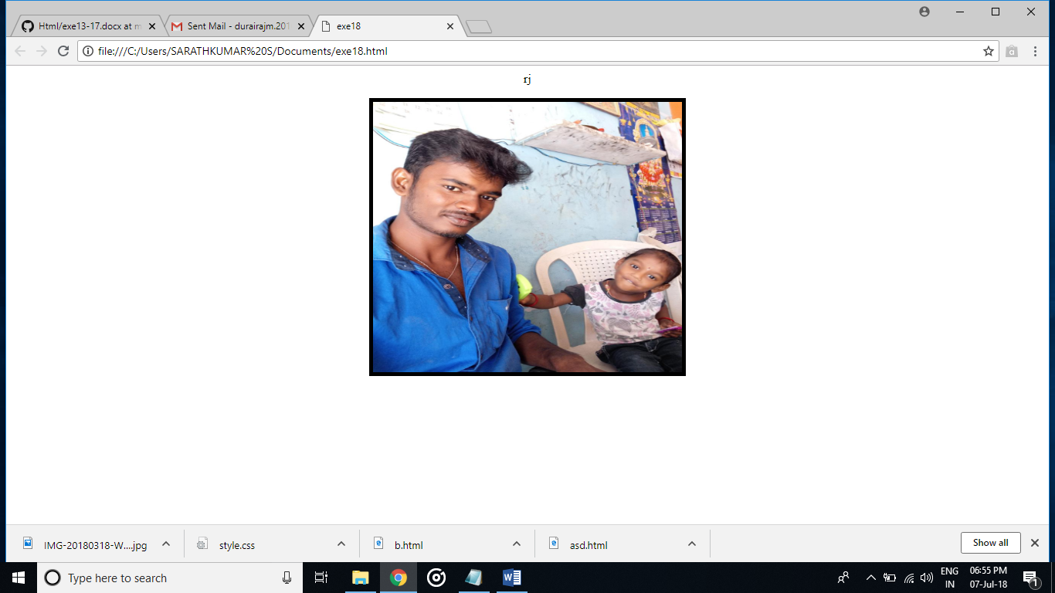

PROGRAM:

<!--Basic table-->

<html>

<head>

<title>exe19</title>

</head>

<body>

<p><b>DurairajM</b></p>

<table border="2">

<tr>

<th rowspan="2"colspan="2">

<th>Mark</th>

<th>Grade</th>

<tr>

<td>87</td>

<td>A</td>

</html>

OUTPUT:

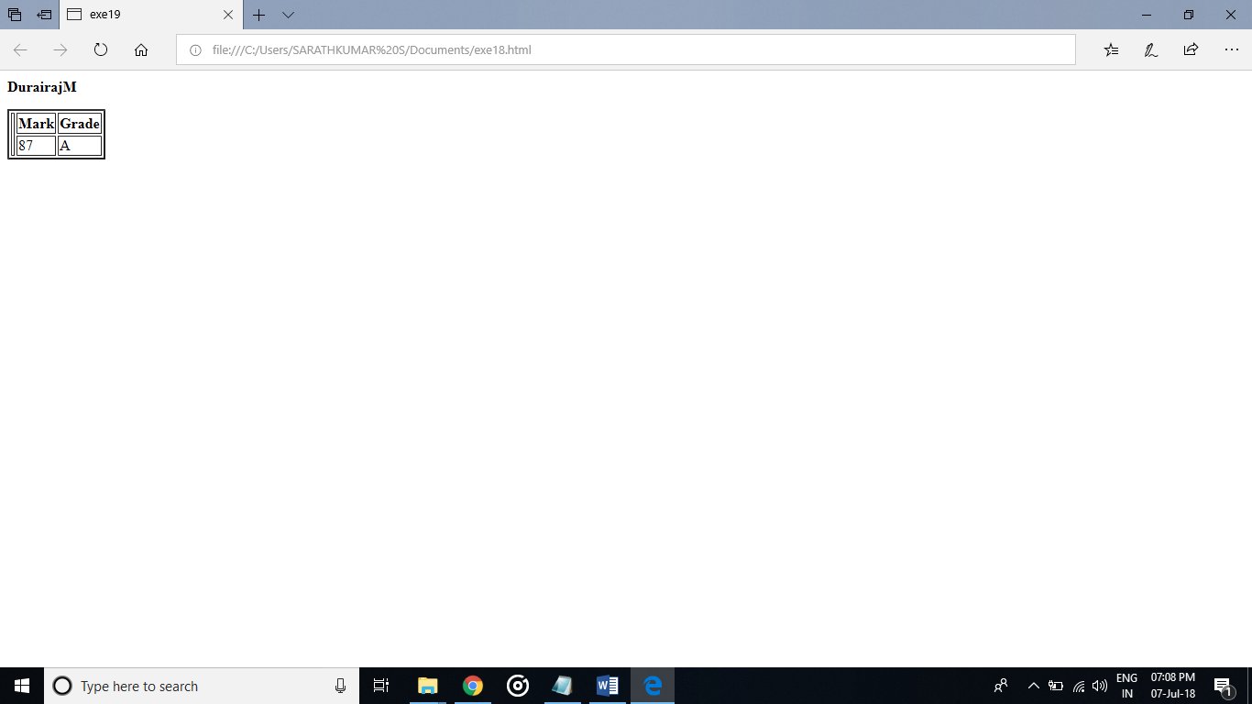

PROGRAM:

<!--Basic table with colors-->

<html>

<head>

<title>exe20</title>

</head>

<body>

<p><b>DurairajM</b></p>

<table bgcolor="skyblue" border="2">

<tr>

<th rowspan="2"colspan="2">

<th>Mark</th>

<th>Grade</th>

<tr>

<td>87</td>

<td>A</td>

</tr>

</html>

OUTPUT:

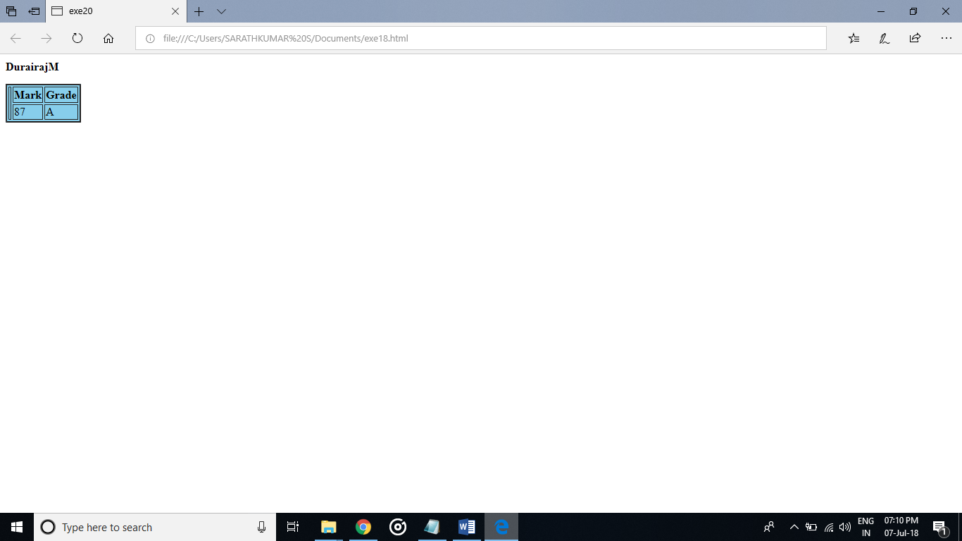

PROGRAM:

<!--Basic table with spaning-->

<html>

<head>

<title>exe21</title>

</head>

<body>

<p><b>DurairajM</b></p>

<table border="2">

<th rowspan="2"colspan="3">

<th>Mark</th>

<th>Grade</th>

<tr>

<td>87</td>

<td>A</td>

<td>6</td>

</tr>

</html>

OUTPUT:

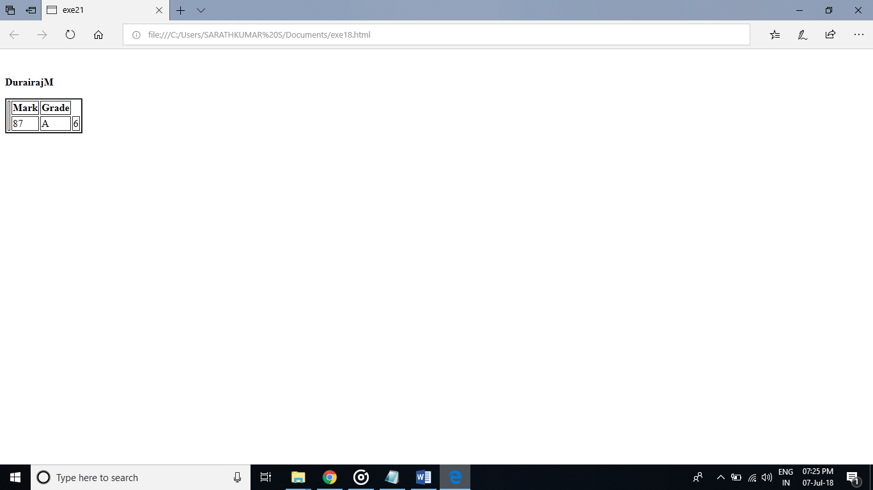

PROGRAM:

<!--Basic table with cell spacing and cell padding-->

<html>

<head>

<title>exe22</title>

</head>

<body>

<p><b>DurairajM</b></p>

<table border="2">

<th rowspan="2"colspan="3">

<th>Mark</th>

<th>Grade</th>

<tr>

<td>87</td>

<td>A</td>

<td>6</td>

</tr><br>

<table border="2">

<th rowspan="2"colspan="3">

<th>Mark</th>

<th>Grade</th>

<tr>

<td>87</td>

<td>A</td>

<td>6</td>

</tr>

</body>

</html>

OUTPUT:

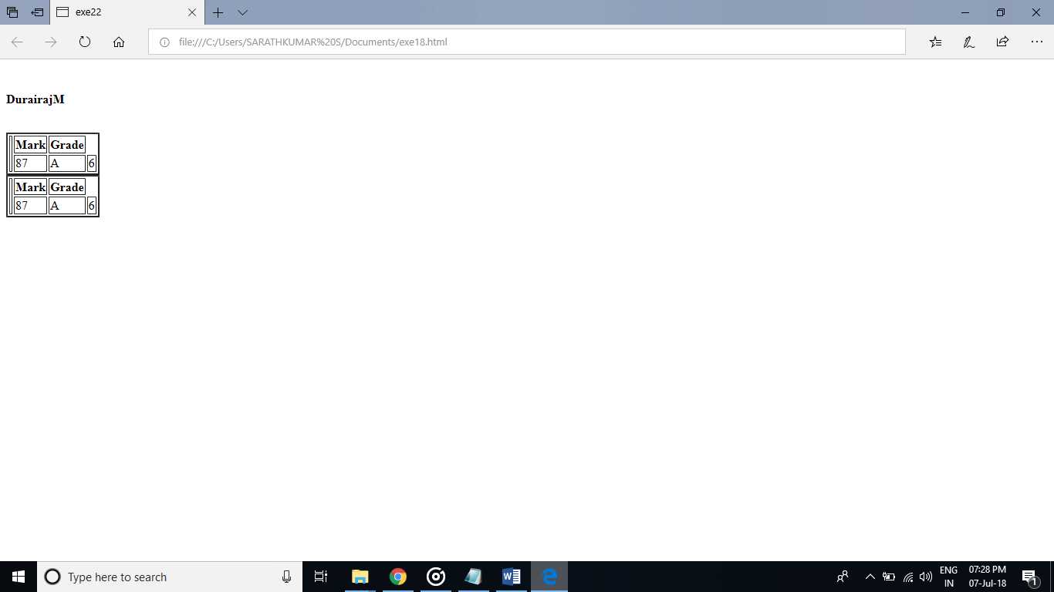

PROGRAM:

<!--bgcolor attribute-->

<html>

<head>

<title>exe23</title>

</head>

<body bgcolor="grey">

<p><b>DurairajM</b></p>

</body>

</html>

OUTPUT:

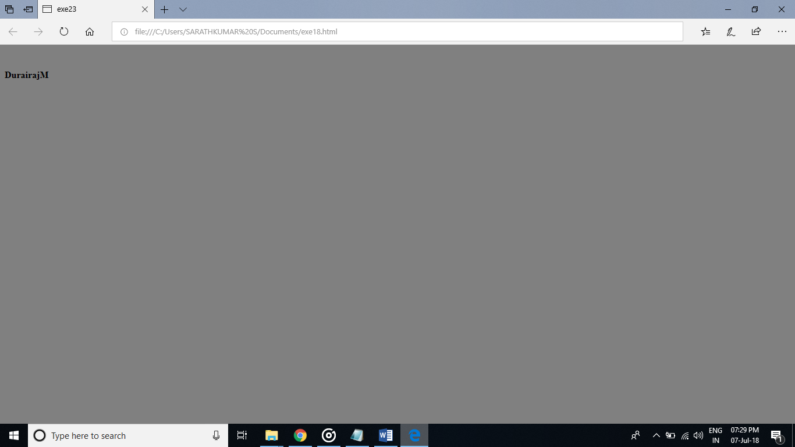

PROGRAM:  
<!—background img-->

<html>

<head>

<title>exe24</title>

</head>

<body background="rj1.jpg" >

<p><b>Durairaj M</b></p>

</body>

</html>

OUTPUT:  
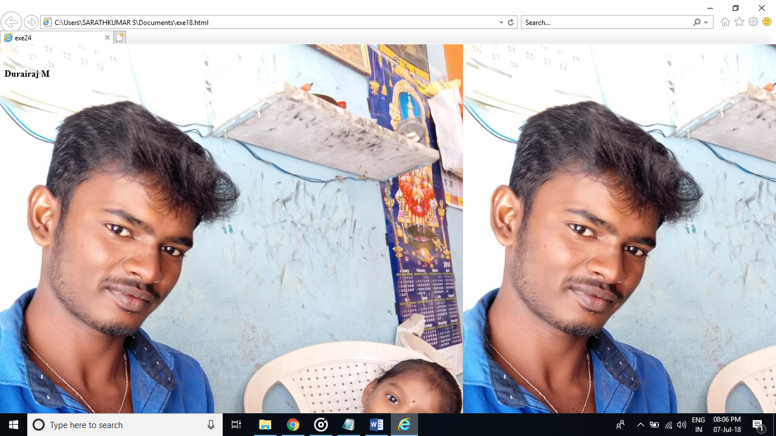

PROGRAM:  
<!--Internal css-->

<html>

<title>exe26</title>

<style>

body {background-color:pink;}

p {

color:blue;

font-size:30;

font-family:lemon;

}

</style>

</head>

<body>

<b><i> Durairaj M --IT</b></i></p>

</body>

</html>

OUTPUT:

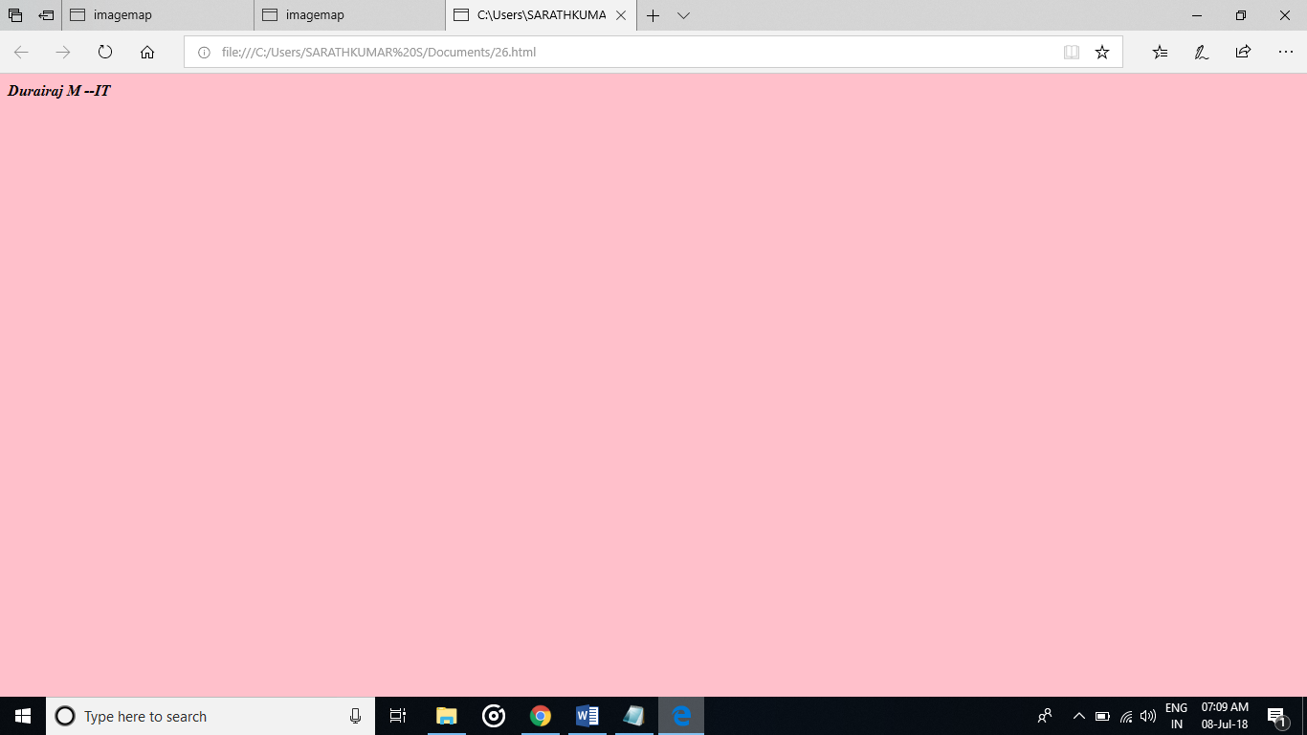

PROGRAM:  
<!--External css-->

<html>

<head>

<title>exe27</title>

<link rel="stylesheet"type="text/css">

<a href="style.css></a>

</head>

<p>Hiiii</p>

</body>

</html>

OUTPUT:

PROGRAM:

<!--inline css-->

<html>

<title>28</title>

<body>

<h1 style="background-color:blue"> <i>Durairaj M</i></h1>

</body></html>

OUTPUT:  
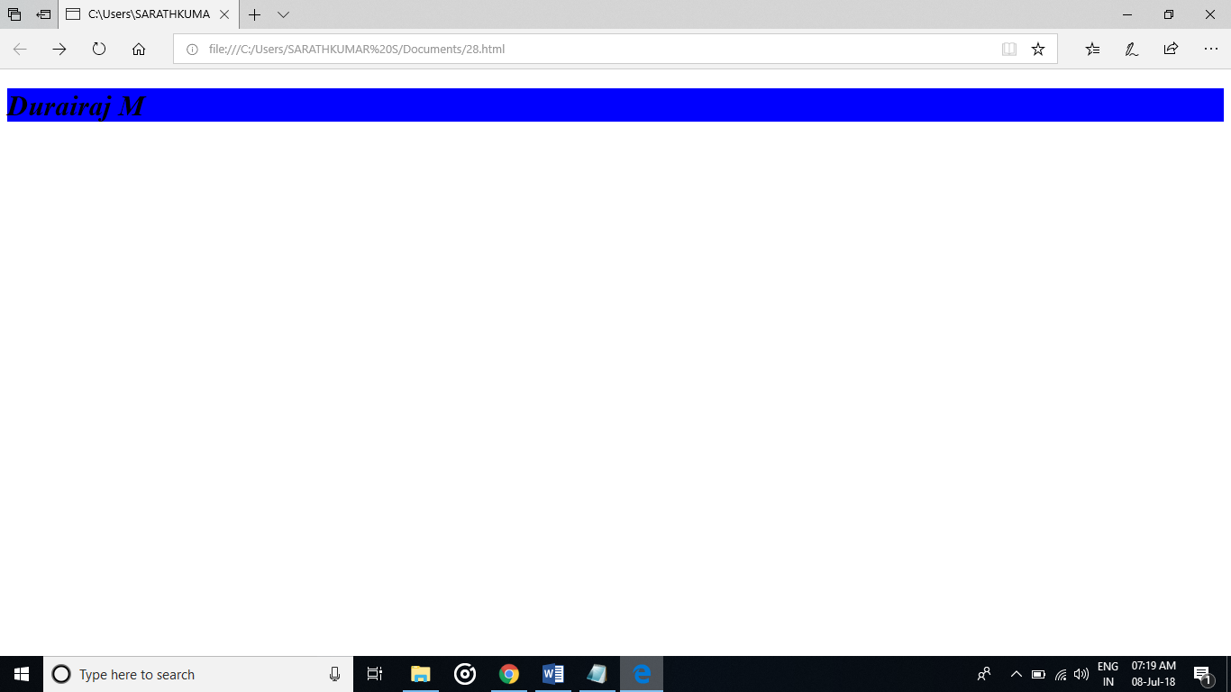

PROGRAM:  
<!--css background-->

<html>

<title>30</title>

<style>

body {

background-color: pink;

}

</style>

</head>

<body>

<h1>css background color</h1>

<p><b><i>Durairaj M......IT</i></b></p

</body>

</html>

OUTPUT:

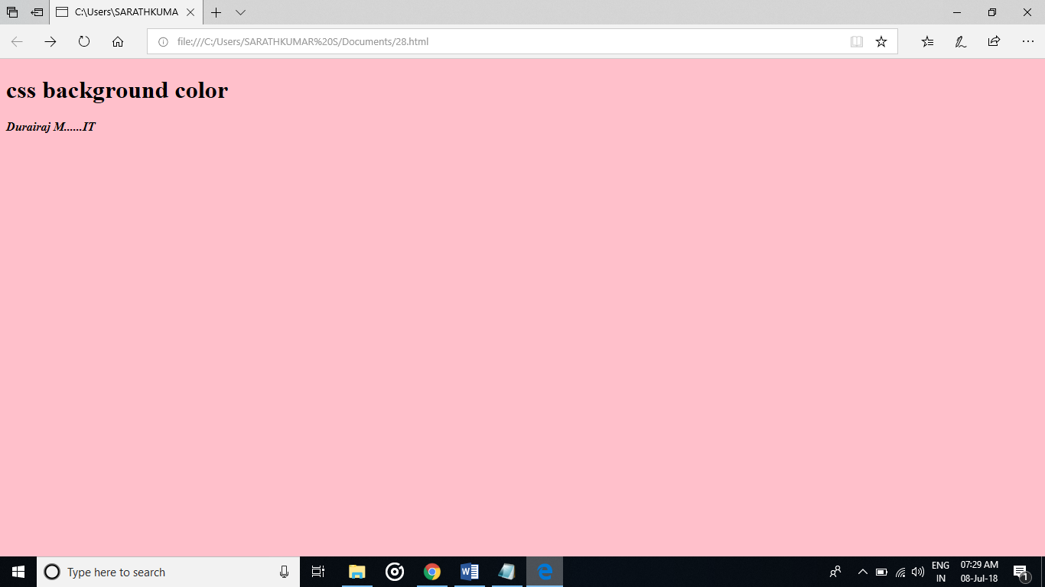

PROGRAM:

<!--css classes-->

<html>

<title>29</title>

<body>

<style>

a:active {

background-color: black;

}

a:visited {

color: red;

}

a:hover {

background-color: yellow;

}

a:link {

color: blue;

}

</style>

</head>

<body>

<a href="https://www.google.com/">Google Home</a><br>

<a href="https://www.gmail.com/">Gmail</a><br>

<a href="http://www.github.net/">Github</a><br>

</body>

</html>

OUTPUT:  
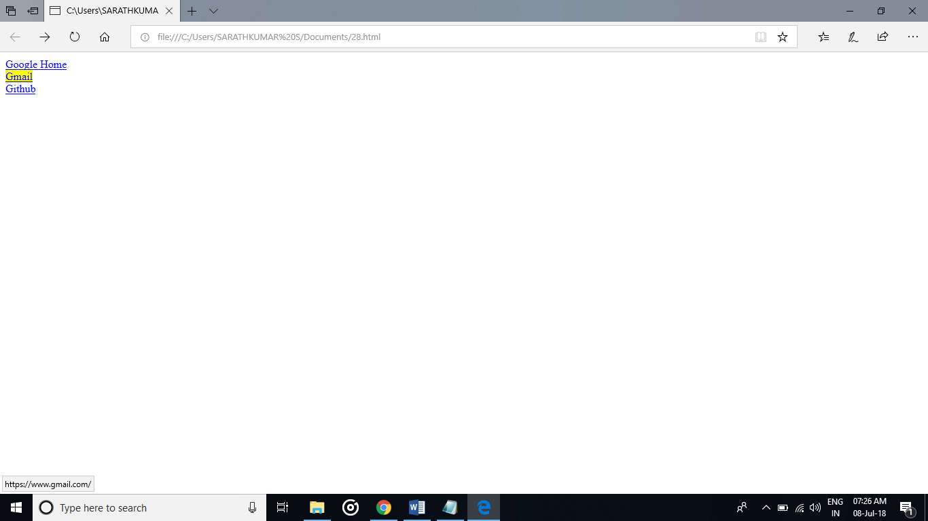



PROGRAM:  
<!--css font-->

<html>

<title>31</title>

<body>

<p style="font-family:lemon;font-size:18;text-align:center">

<b><i>Duraiiiiiii</b></i></p>

</body>

</html>

OUTPUT:

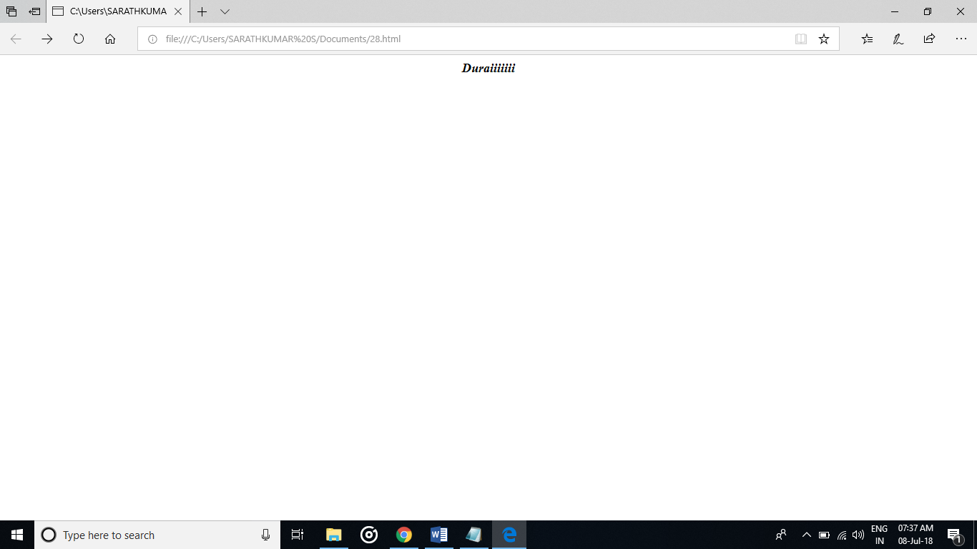

PROGRAM:  
<!--css text-->

<html>

<title>32</title>

<style>

body {

background-color: pink;

}

</style>

</head>

<body>

<h1>css background color</h1>

<p><b><i>Durairaj M......IT</i></b></p

</body>

</html

OUTPUT:



PROGRAM:

<!--css padding-->

<html>

<title>33</title>

<style>

div {

padding: 100px 100px 100px;

border: 1px solid red;

}

</style>

</head>

<body>

<div><i>Duriiiii.....</i></div>

</body>

</html>

OUTPUT:

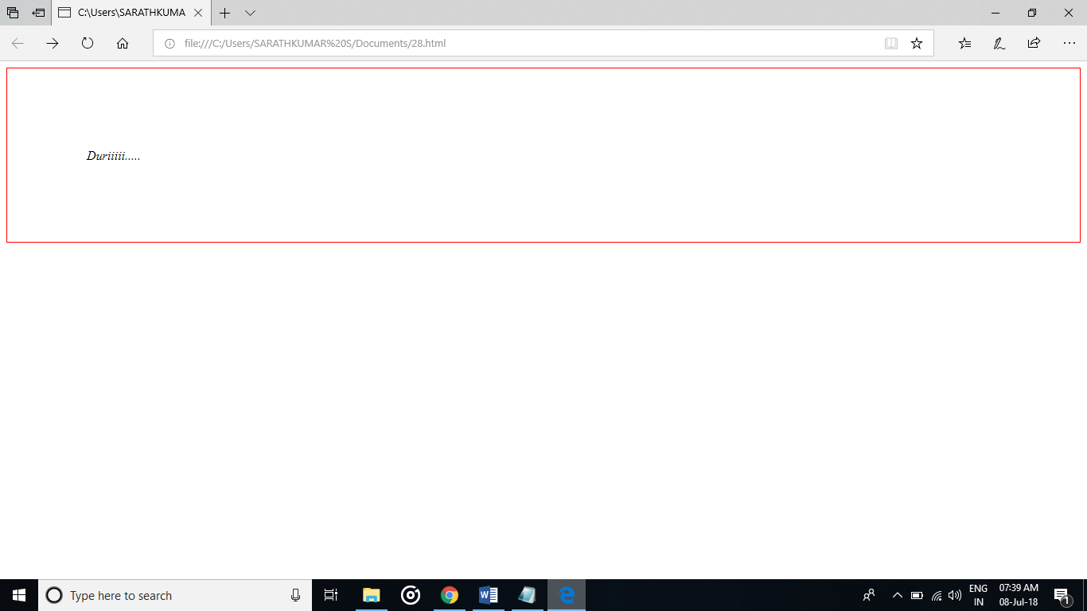

PROGRAM:  
<!--css margin-->

<html>

<title>34</title>

<style>

div {

margin: 100px 70px 100px;

border: 5px solid ;

}

</style>

</head>

<body>

<div><i>duriii</i></div>

</body>

</html>

OUTPUT:

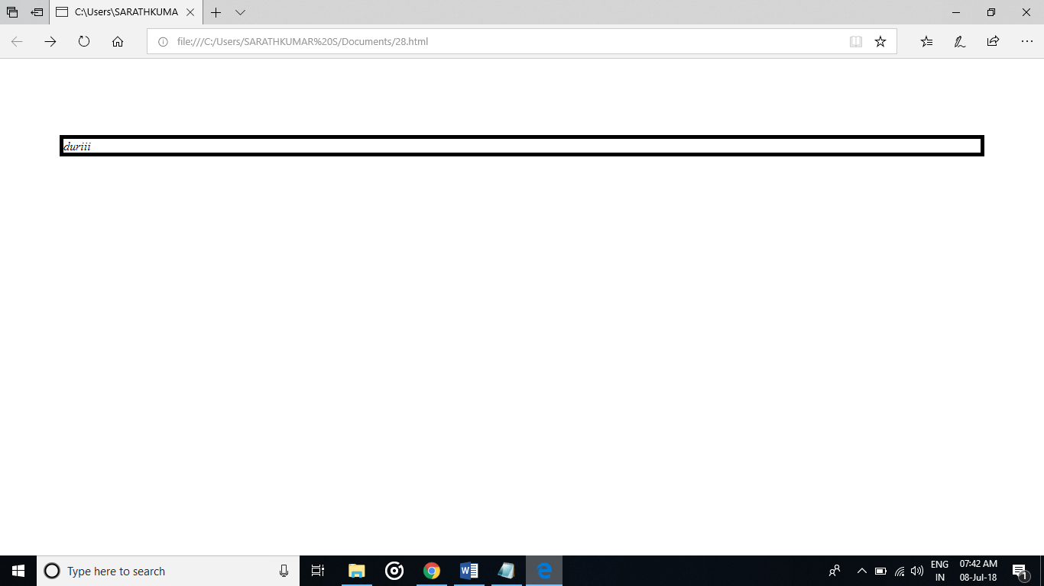

PROGRAM:

<!--css border-->

<html>

<title>35</title>

<style>

div {

border-style:double;

border-color:blue ;

}

</style>

</head>

<body>

<div><i>duriii</i></div>

</body>

</html>

OUTPUT:

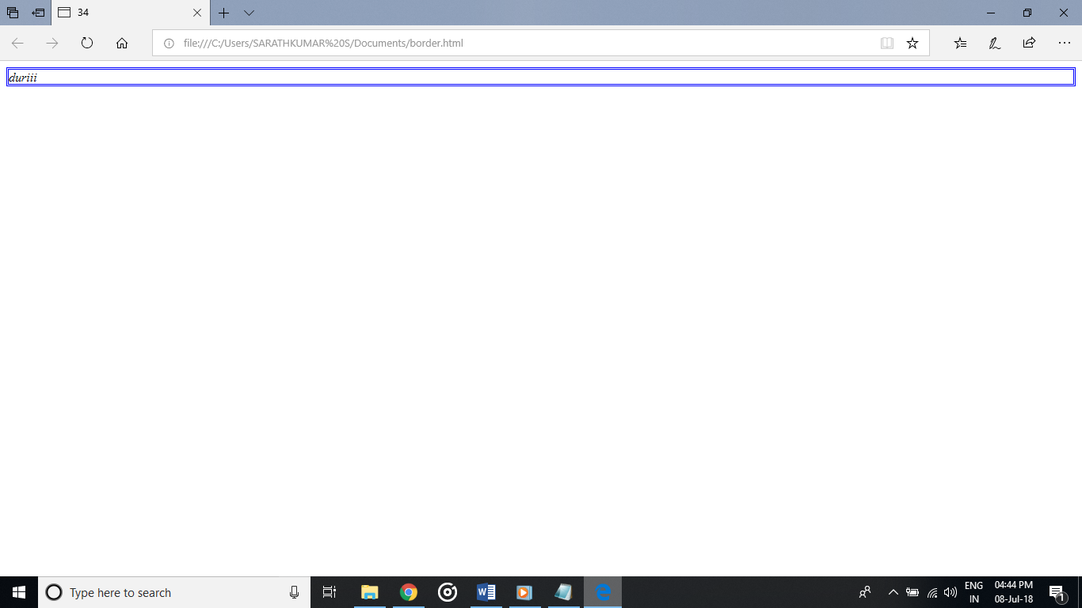

PROGRAM:  
<!--css list-->

<html>

<title>36</title>

<style>

ul.a

{

list-style-type:circle;

}

ol.b

{

list-style-type:upper-roman;

</style>

</head>

<body>

<p>unordered list</p>

<ul class="a">

<li>durai</li>

<li>ram </li>

<li>arun</li>

</ul>

<p>ordered list</p>

<ol class="b">

<li>durai</li>

<li>ram </li>

<li>arun</li>

</ol>

</body>

</html>

OUTPUT:

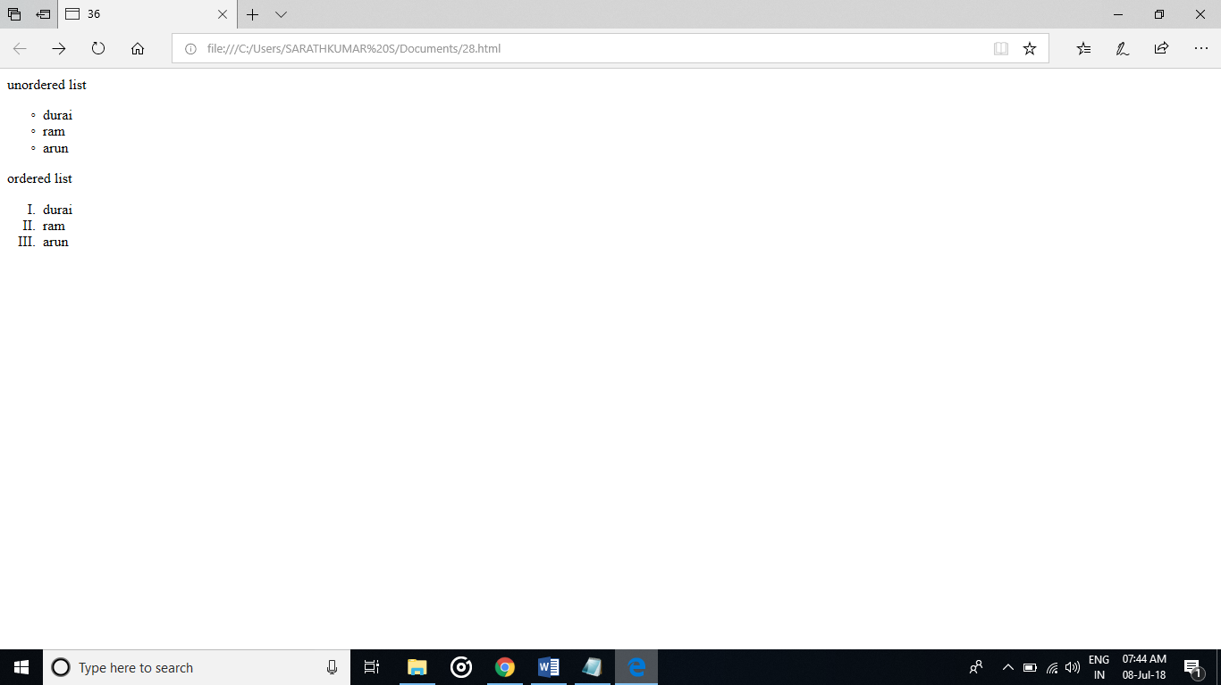

PROGRAM:  
<!--css links-->

<html>

<title>37</title>

<style>

a.DUR:link {color:brown;}

a.DUR:hover {color:black;}

a.RAM:link {color:brown;}

a.RAM:hover {font-size:100;}

a.RAJ:link {color:brown;}

a.RAJ:hover {background:orange;}

a.SAT:link {color:brown;}

a.SAT:hover {font-family:Castellar;}

</style>

</head>

<body>

<b>THE LINK WILL GO TO MY GITUP LOGIN PAGE</b></p>

<p><a class="DUR" href="https://github.com">CLICK HERE FOR GITHUB</a></p>

<p><a class="RAM" href="https://google.com">CLICK HERE FOR GOOGLE</a></p>

<p><a class="RAJ" href="https://facebook.com">CLICK HERE FOR FACEBOOK</a></p>

<p><a class="SAT"href="https://gmail.com">CLICK HERE FOR GMAIL</a></p>

</body>

</html>

OUTPUT;

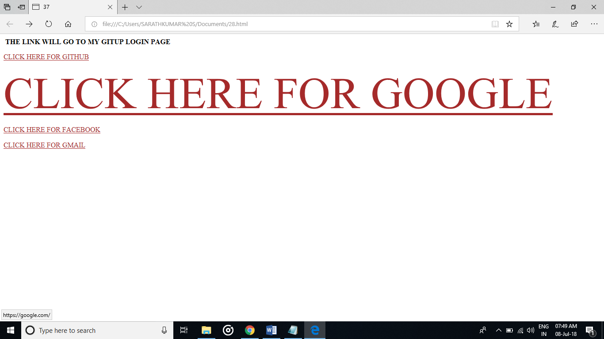

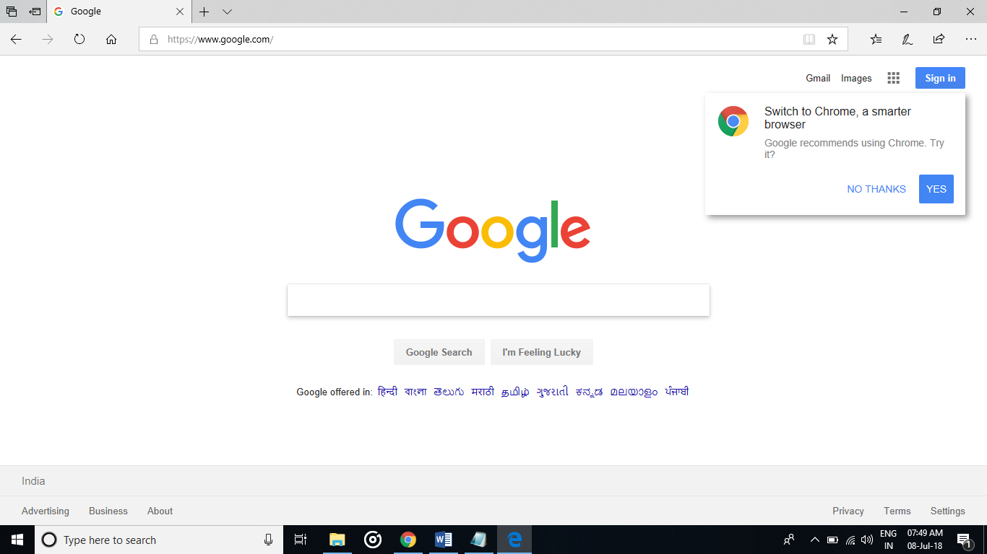

PROGRAM:  
<!--Cascading style sheets-->

<html>

<head>

<title>exe38</title>

<style>

body{background-color:skyblue;}

p{color:green;}

h1{color:white;}

table,tr,td{color:white;

border:1px solid blue;}

th{color:black;}

ul{color:yellow;}

</style>

</head>

<body>

<center><h1> style sheet</h1></center>

<p>Durairaj style sheets</p>

<h1>college details</h1>

<p> studying B.Tech IT in Rajalakshmi Institute of Technology,Chennai</p>

<table>

<p>my detail</p>

<th>Name</th>

<th>rollno</th>

<tr>

<td>DurairajM</td>

<td>201603018</td>

</tr>

</table>

<h2>hobbies</h2>

<ul style="list-style-type:circle">

<li>vetti busy</li>

<li>listening music</li>

</ul>

</body>

</html>

OUTPUT:  
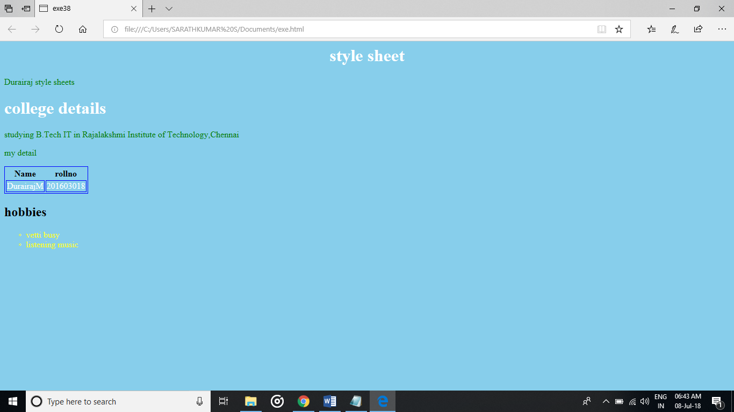

PROGRAM:  
<!--Html Form-->

<html>

<title>39</title>

<style>

input[type=text]

{

color:blue;

}

</style>

</head>

<body>

<p><b>Enter the name</b></p>

<form>

<label="fname">First Name</label>

<input type="text" id ="fname" name="first name" placeholder="your name..">

</form>

<body>

</html>

OUTPUT:  
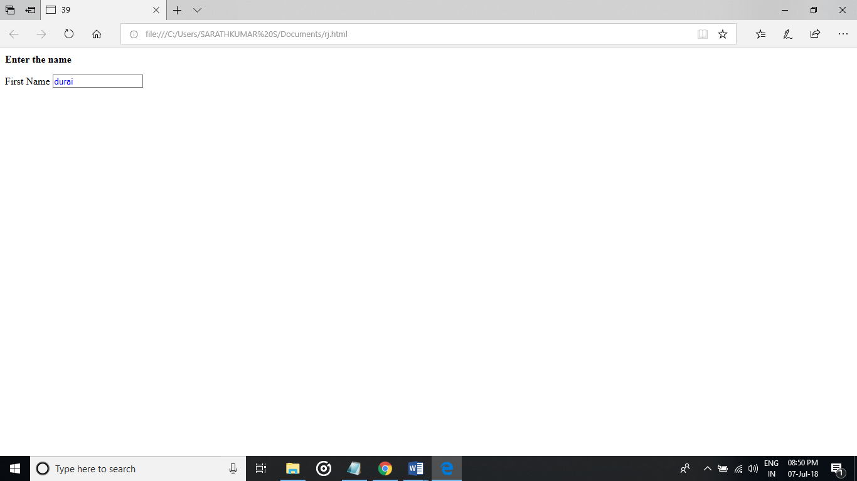

PROGRAM:  
<!--Html Input-->

<html>

<title>40</title>

<style>

input[type]=text

{

background-color:hotpink;

}

</style>

</head>

<body>

<p><b>ENTER YOUR INPUT VALUE</b></p>

<form>

<label ="two">Name</label>

<input type="text" id="two" name="name" placehoder="your name">

<input type="submit" value="submit">

</form>

</body>

</html>

OUTPUT:

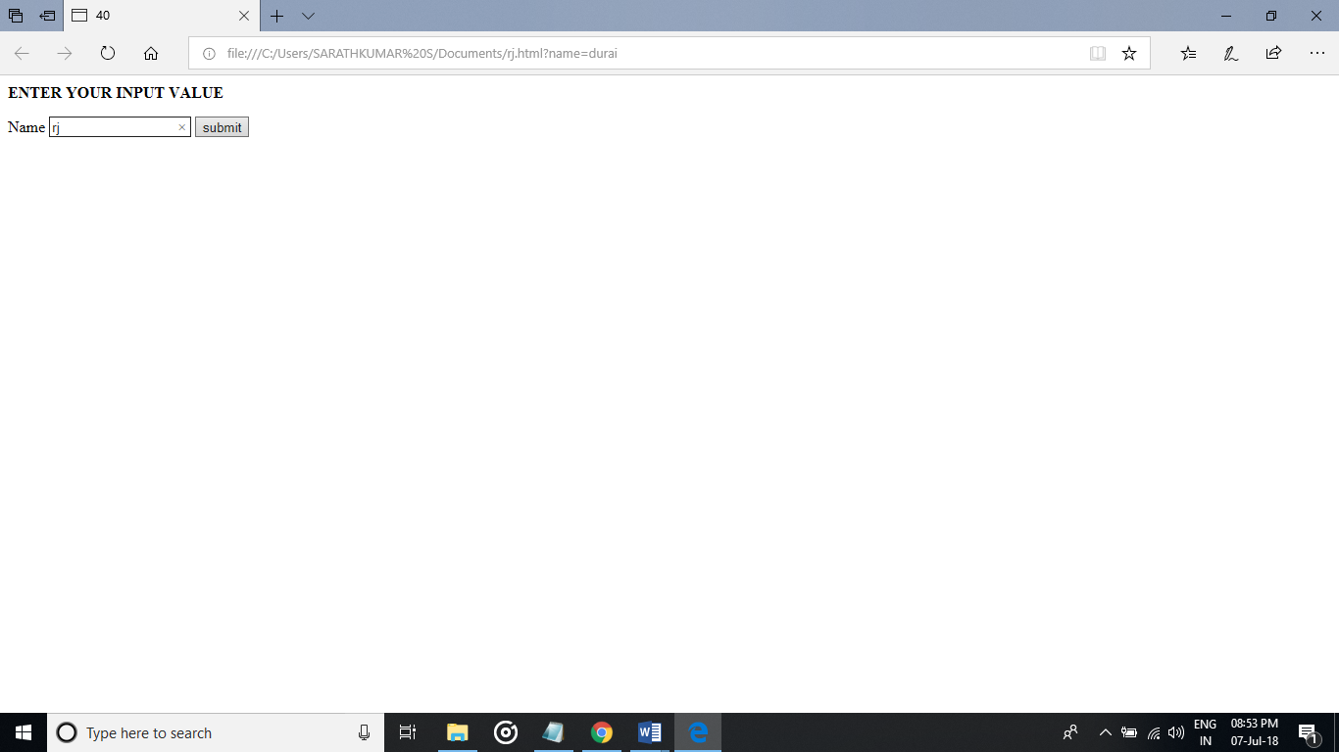

PROGRAM:

<!--Html Reset-->

<html>

<title>exe43</title>

<style>

input[type]=text

{

background-color:hotpink;

}

</style>

</head>

<body>

<p><b>Enter the name</b></p>

<form>

<label ="two">Name</label>

<input type="text" id="two" name="name" placehoder="your name">

<input type="reset" value="reset">

</form>

</body>

</html>

OUTPUT:

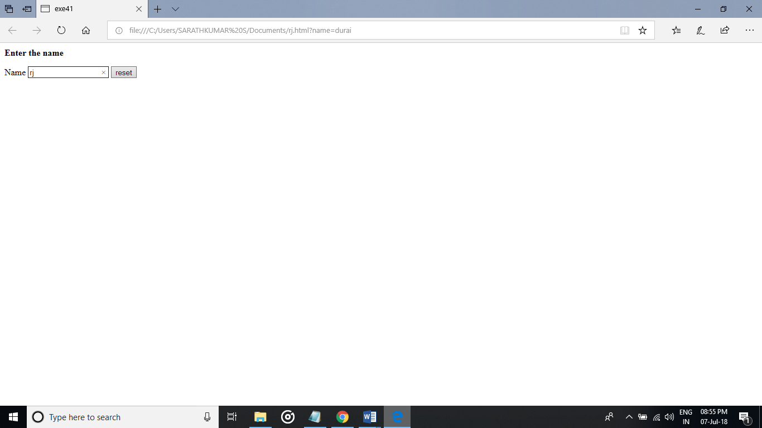

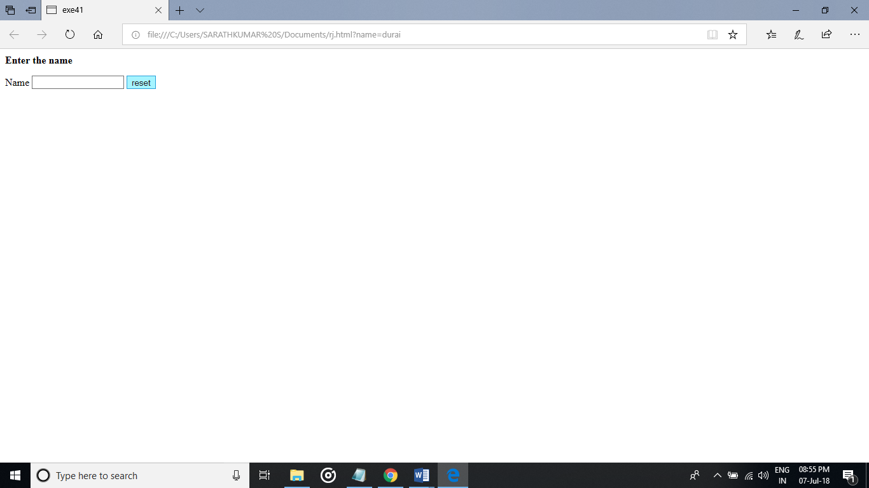

PROGRAM:  
<!--Html Fields-->

<html>

<title>exe41</title>

<style>

input[type=text]

{

background-color:blue;

}

input[type]=password

{

background-color:green;

}

</style>

</head>

<body>

<p><b>Enter the details</b></p>

<div>

<form>

<label for="0">Name</label>

<input type="name" id="0" name="0" ><br>

<label for="1">Password</label>

<input type="password" id="1" name="1">

</form>

</div>

</body>

</html>

OUTPUT:

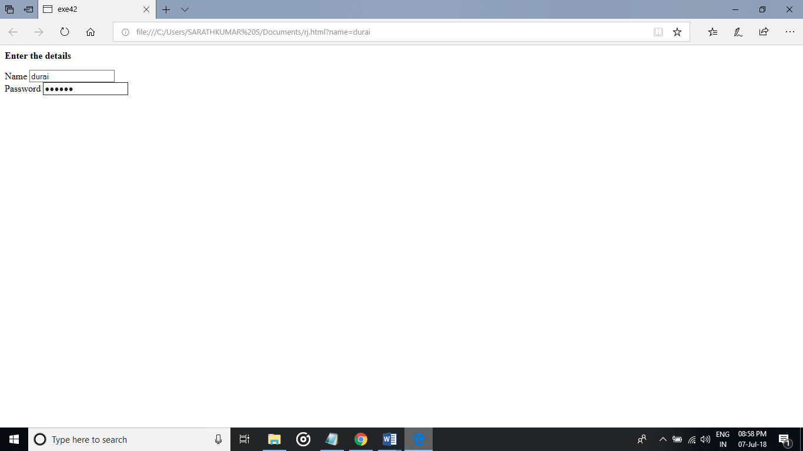

PROGRAM:

<!--Html password-->

<html>

<title>exe42</title>

<style>

input[type=text]

{

background-color:red;

}

input[type]=password

{

background-color:green;

}

</style>

</head>

<body>

<p><b>Enter the id and password</b></p>

<div>

<form>

<label for="1">email id</label>

<input type="email id" id="1" name="1"><br>

<label for="0">password</label>

<input type="password" id="0" name="0">

<input type="submit" id="0" value="submit">

</form>

</div>

</body>

</html>

OUTPUT:

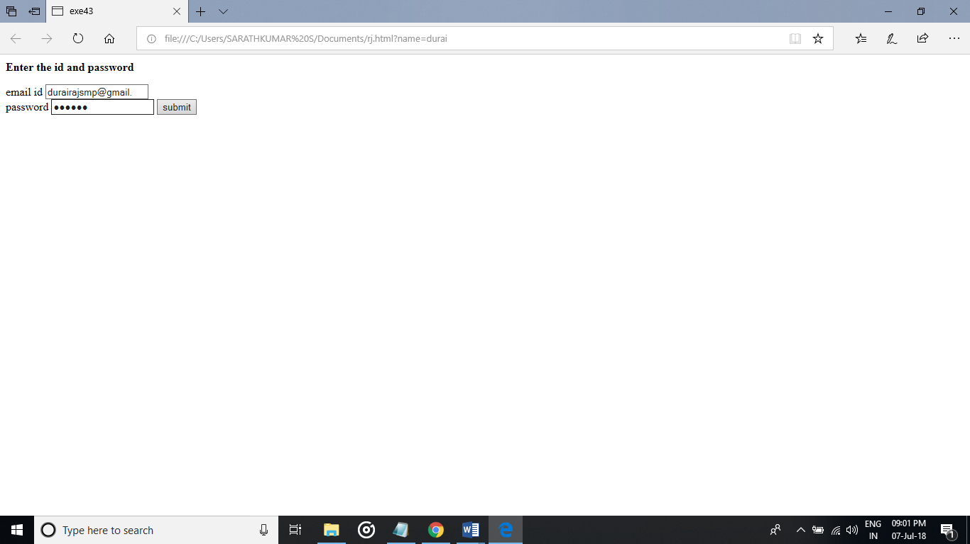

PROGRAM:  
<!--Html submit-->

<html>

<title>exe44</title>

<style>

input[type=text]

</style>

</head>

<body>

<p><b>Enter the comment</b></p>

<div>

<form>

<label for="1">Message</label>

<input type="text" id="1" name="1"><br>

<label for="0">Number</label>

<input type="number" id="0" name="0">

<input type="submit" id="0" value="send">

</form>

</div>

</body>

</html>

OUTPUT:  
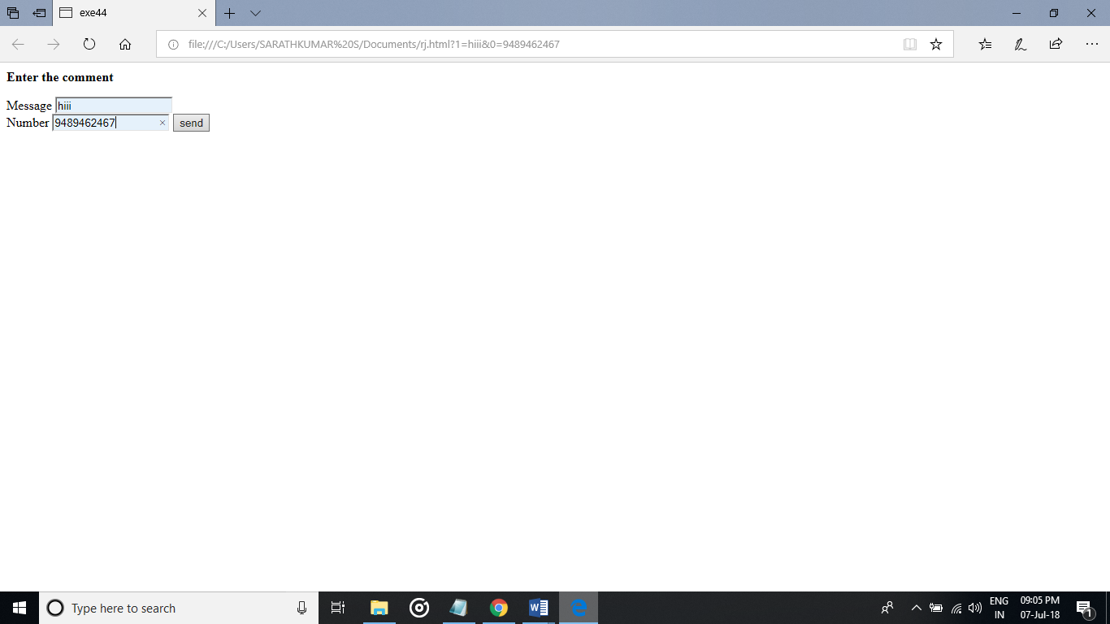

PROGRAM:

<!--Html checkbox-->

<html>

<title>exe45</title>

<style>

input[type=text]

{

background-color:blue;

}

</style>

</head>

<body>

<p><b>SELECT THE GENDER</b></p>

<div>

<form>

<label for="0">Male</label>

<input type="checkbox" id="0" name="0"><br>

<label for="0">Female</label>

<input type="checkbox" id="0" name="0">

<input type="submit" id="0" value="submit">

</form>

</div>

</body>

</html>

OUTPUT:

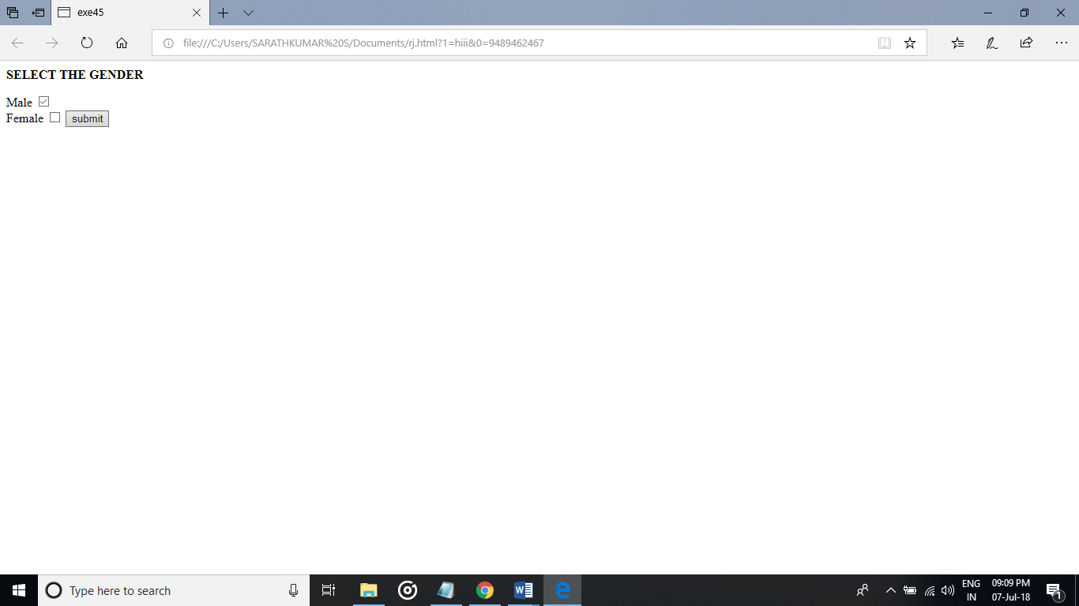

PROGRAM:

<!--Html radio button-->

<html>

<title>exe46</title>

<body>

<p><b>SELECT THE GENDER</b></p>

<form>

<label for="0">Male</label>

<input type="radio" id="0" name="0"><br>

<label for="0">Female</label>

<input type="radio" id="0" name="0">

<input type="submit" id="0" value="submit">

</form>

</body>

</html>

OUTPUT:

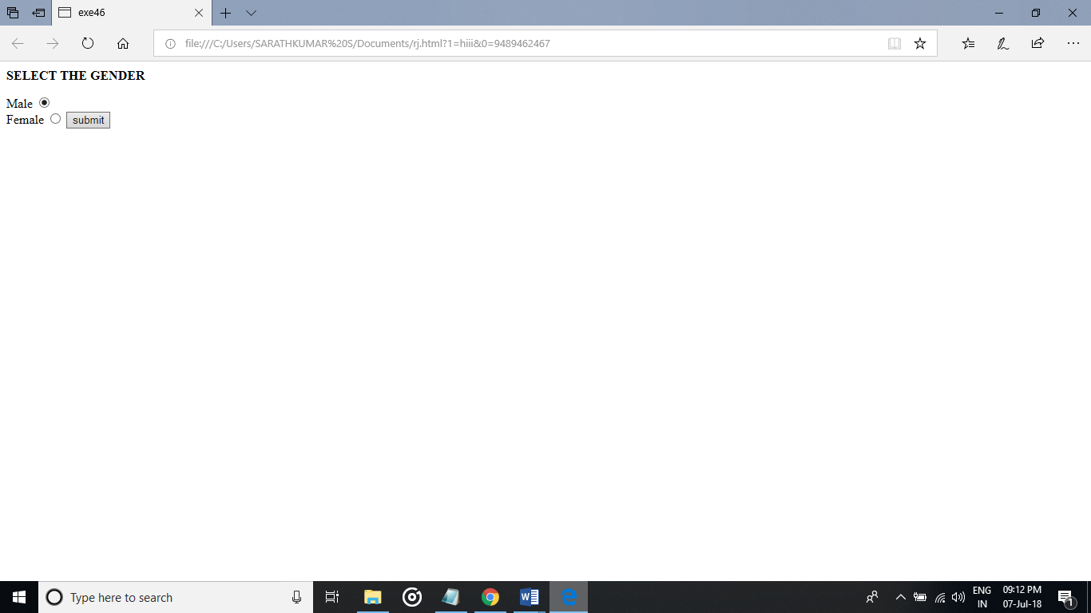

PROGRAM:

<!--Html Select-->

<html>

<title>exe47</title>

<style>

input[type=text]

{

background-color:red;

}

</style>

</head>

<body>

<p><b>Select the number</b></p>

<form>

<p>SELECT </p>

<select>

<option value="1">1</option>

<option value="2">2</option>

<option value="3">3</option>

<input type="submit" value="submit">

</select>

</form>

</body>

</html>

OUTPUT:

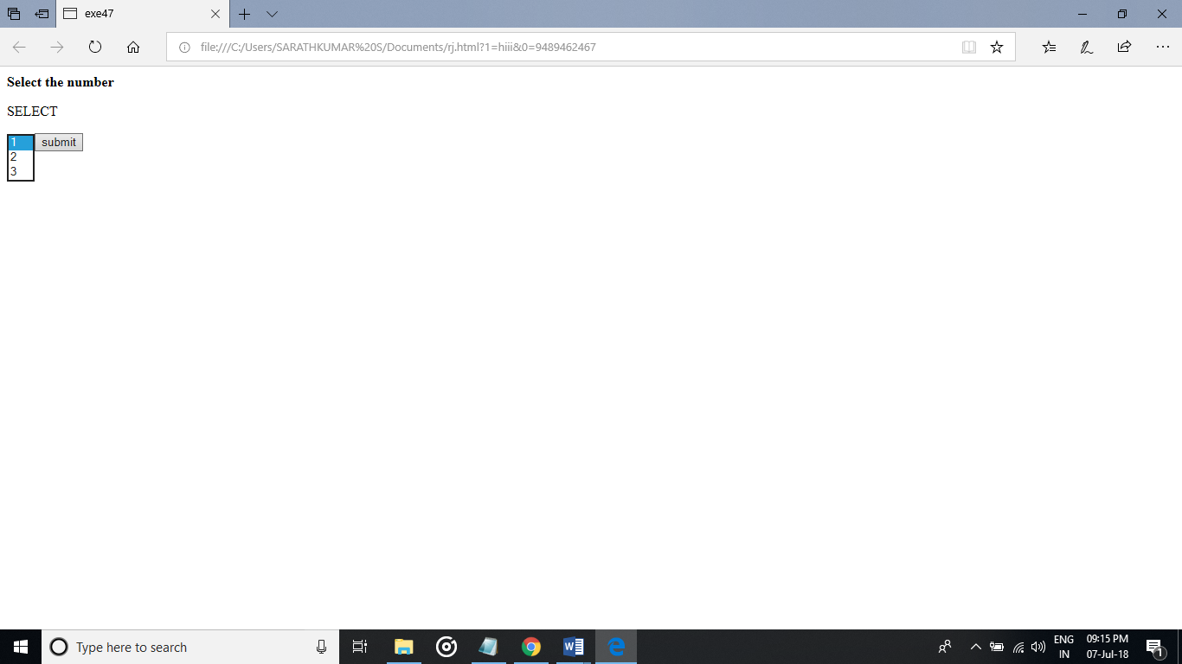

PROGRAM:  
<!--Html Hidden Value-->

<html>

<title>exe48</title>

<style>

input[type=text]

{

background-color:red;

}

</style>

</head>

<body>

<p><b>Select the number</b></p>

<form>

<p>SELECT </p>

<select>

<option value="1">1</option>

<option value="2">2</option>

<option value="3">3</option>

<input type="hidden" value="submit">

</select>

</form>

</body>

</html>

OUTPUT:  
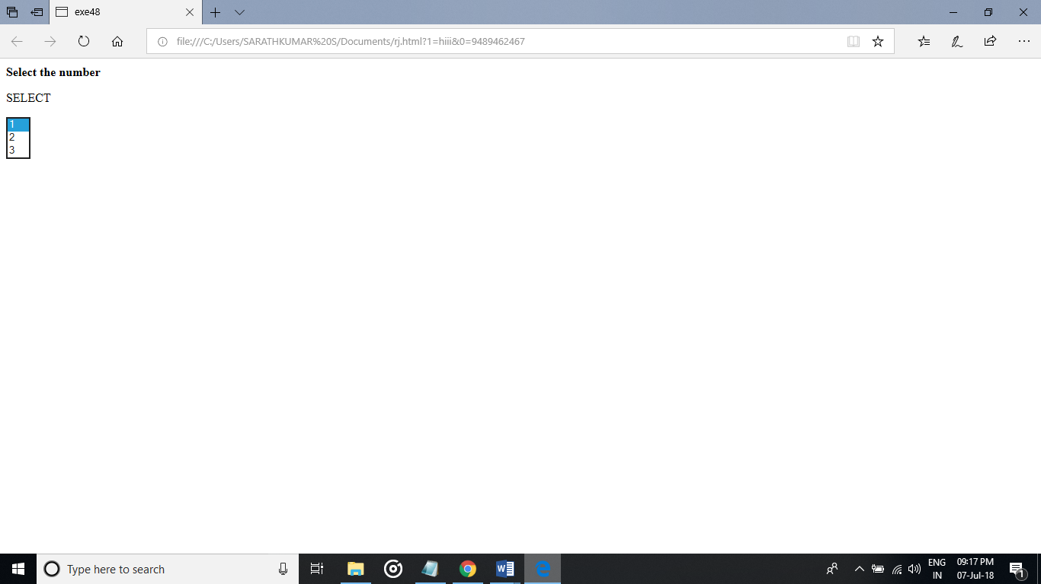

PROGRAM:

<!--Html fileupload-->

<html>

<title>exe49</title>

<body>

<p>choose file</p>

<forms>

<input type="file" >

</forms>

</head>

</html>

OUTPUT:  
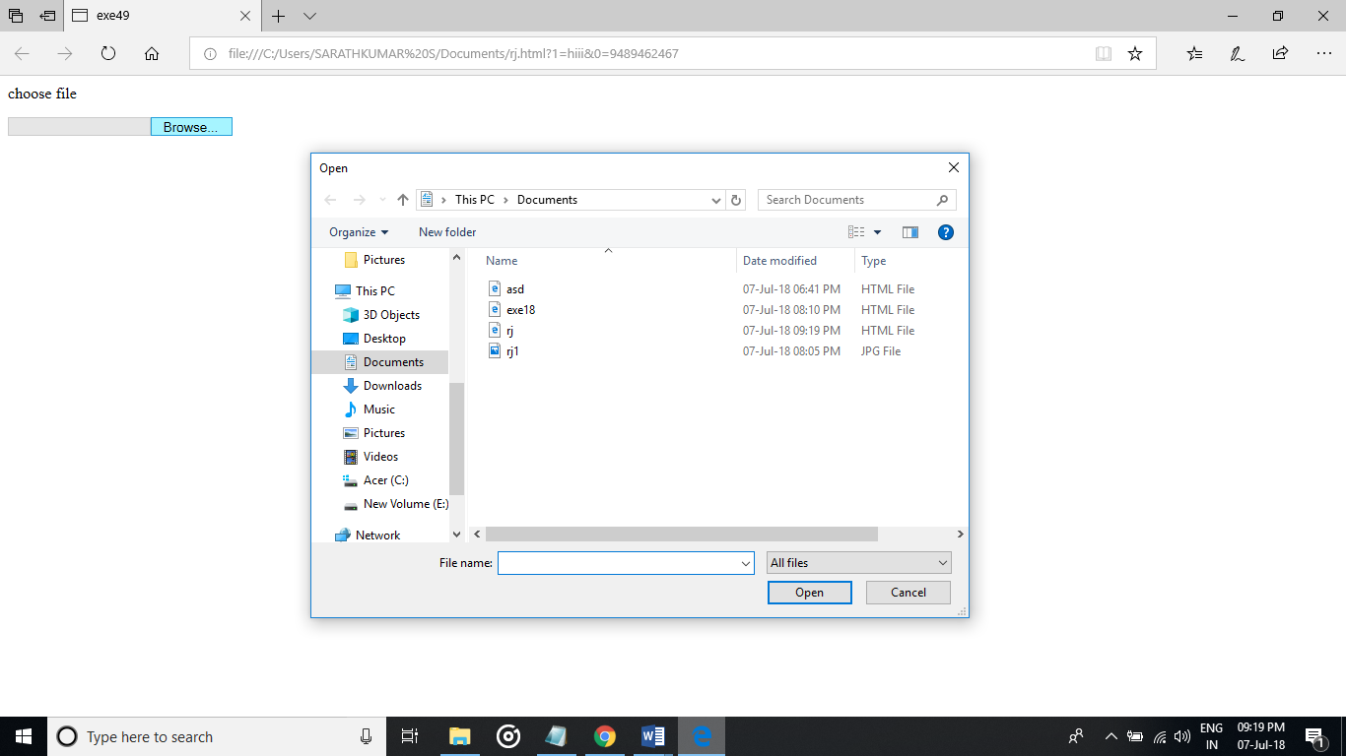

PROGRAM:  
<!--Html Text Area-->

<html>

<head>

<title>ex50</title>

</head>

<body>

<textarea rows="6" cols="15">

Enter the text in this area</textarea><br>

<textarea rows="6" cols="20">

This area is of 6 rows and 20 columns space for texting

</textarea><br>

<br>

</body>

</html>

OUTPUT:

